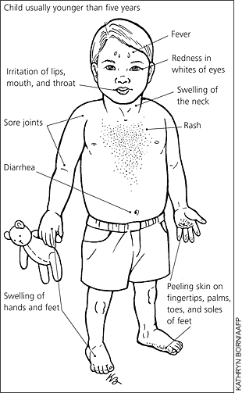 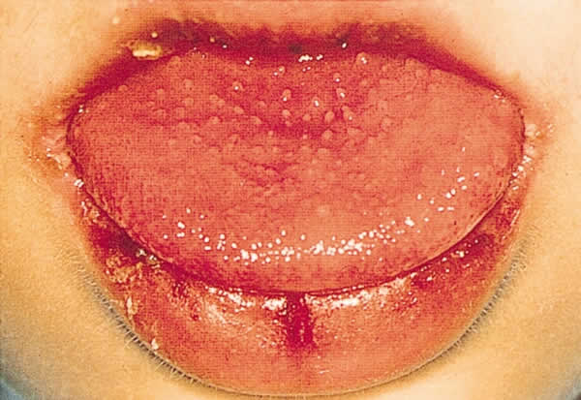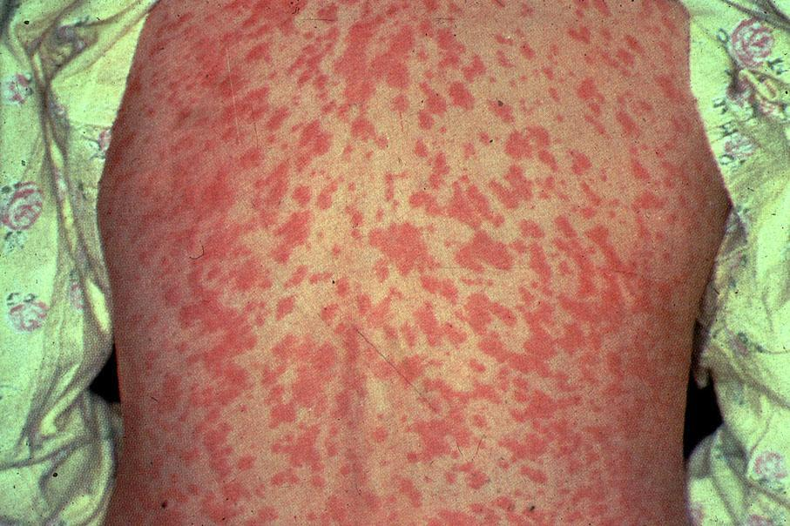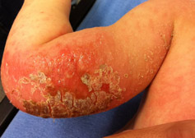

A child, age 3, is hospitalized for treatment of Kawasaki disease. During the acute stage of this disease, nurse Ashley must assess the child frequently for what: a) heart failure b) kidney failure c) desquamation of the hands and feet d) hepatitis

The nursing care plan for a toddler diagnosed with Kawasaki Disease should be based on the high risk for development of which problem? a) Chronic vessel plaque formation b) Pulmonary embolism c) Occlusions at the vessel bifurcations d) Coronary artery aneurysms

NCLEX Questions:

Kawasaki disease is a condition that causes inflammation in the walls of small and medium sized arteries throughout the body, including the coronary arteries, which supply blood to the heart muscle. Kawasaki disease is also called mucocutaneous lymph node syndrome because it also affects lymph nodes, skin, and the mucous membranes inside the mouth, nose and throat. Kawasaki disease is primarily a condition of young children. Eight percent of cases are seen in young children younger then 5 years of age. Males are affected slightly more than females. The etiology of Kawasaki disease remains unknown. Current etiologic theories center the disease on an immunologic response to an infectious, toxic, or antigenic agent. The peak incidence is in the winter and spring. It is seen more in Asians, less among white children, and rare in black children.

Kawasaki disease progresses in different stages. In the acute phase, small capillaries, arterioles, and venules becomes inflamed, as does the heart itself. In the subacute phase, inflammation spreads to larger vessels and aneurysms of the coronary artery develop. In the convalescent stage, medium sized arteries begin the granulation process and may cause coronary artery thickening with increased right for thrombosis. After the convalescent stage, inflammation wanes with potential scaring of the affected vessels, calcification and stenosis.

## Pathophysiology of Kawasaki Disease.

### Kawasaki Disease:

## Explanation of Kawasaki Disease:

The clinical manifestations for Kawasaki disease are the child must have a fever for five or more days; it can be diagnosed with shorted duration of fever if other symptoms are present. The child will have bilateral conjunctival infection without exudation. There will be changes in the oral mucous membranes, such as erythema, dryness, and fissuring of the lips. There will also be oropharyngeal reddening or “strawberry tongue”. The extremities will show change such as peripheral edema, peripheral erythema, and desquamation of palms and soles, particularly periungual peeling. The child will present with polymorphous rash, often accentuated in the perineal area and cervical lymphadenopathy. Potential complications of this disease are Kawasaki disease is a leading cause of acquired heart disease in children. Heart complications include: inflammation of the heart muscle, heart valve problems, abnormal heart rhythm, and inflammation of blood vessels, usually the coronary arteries, that supply blood to the heart. Inflammation of the coronary arteries can lead to weakening and bulging of the artery wall. Aneurysms increase the risk of blood clots forming and blocking the artery, which could lead to a heart attack or cause life-threatening internal bleeding.

Clinical Manifestations and Potential Complications:

* Mayo Clinic Staff. (2011, January 28). *Kawasaki disease*. Retrieved from <http://www.mayoclinic.com/health/kawasaki-disease/DS00576/DSECTION=symptoms>
* Huether, S. E., & McCance, K. L. (2012). *Understanding pathophysiology* (5th ed.). St. Louis, MO: Mosby Elsevier.
* Healthwise. (2011, December 07). *Kawasaki disease-topic overview*. Retrieved from http://www.webmd.com/heart-disease/tc/kawasaki-disease-topic-overview

References:

The first nursing diagnoses is Impaired oral mucosa membrane r/t inflamed mouth and swollen lips that become dry, cracked, and fissured. Outcome criteria for this nursing diagnosis would be to maintain intact, moist oral mucous membranes that are free of ulceration, inflammation, infection and debris within two weeks. Demonstrate measures to maintain or regain intact oral mucous membranes within five weeks. The second nursing diagnosis is Impaired skin integrity r/t inflammatory skin changes. Outcome criteria for this nursing diagnosis would be to regain integrity of skin surface within three weeks. Demonstrate understanding of plan to heal skin and prevent re-injury within two weeks. The third nursing diagnosis is Acute pain r/t erythematous skin rash that progresses to desquamation, peeling, and denuding of skin. Outcome criteria for this nursing diagnosis would be to notify a member of the health care team promptly for pain level greater then the comfort-function goal or occurrence of adverse effect within thirty minutes of onset of pain. Decrease in pain related behaviors within three weeks.

The legal and ethical responsibilities of a nurse in treating a child for Kawasaki disease are to: monitor the vital signs every hour, note the persistence of fever and refer to the physician, encourage increase of fluid intake if patient is not vomiting, provide comfortable clothes for the child, alley the fears and hopes of the family, and observe proper hand washing before and after each nursing procedure in order to prevent further infection. If the incidence of Kawasaki disease increases it will impact nursing by increasing the demand for nurses more, causing inadequate supplies for treatment, reduced staff and increasing overtime and also patient safety. If we have more patients and not enough nurses that is a mixture for inadequate health care. Other health care providers that are involved in the care of patients with Kawasaki disease are the physician, nurses, nurses aids, and a cardiologist if the disease progresses.

Nursing Diagnoses:

Significance to Nursing:

Kawasaki disease is only prevalent in children. Kawasaki disease typically affects children under 5 years of age. Only rarely does it affect children over 8 years of age, in which case it is sometimes referred to as atypical Kawasaki's disease. The disease is not seen in adults or older adults. Kawasaki disease occurs more often in Japan than in any other country. In the US, children of Asian or Asian American heritage are affected more often than other races, although Kawasaki disease can occur in any racial or ethnic group. Kawasaki disease is fairly common in the US. According to the American Heart Association, the illness is a major cause of heart disease in children. About 4,000 children are diagnosed in the US each year. Kawasaki disease, together with acute rheumatic fever, is the leading cause of acquired heart disease in children in the US and Japan. The vast majority of children who develop Kawasaki disease are under age five. The average age child seen with the illness is two years old. It occurs in boys twice as often as in girls.

# Lifespan and Cultural considerations: